Time Entry Using Time & Attendance
Using the options in the Employee Actions module of Time & Attendance, powered by ExecuTime®, you can record your hours worked, request time-off, review your time cards, and submit time for approval.

Supervisors can also use the Employee Actions module to enter, review, and modify time for their subordinate employees. A supervisor can perform any action for their employees in the Employee Actions module except for approving or submitting time as that employee. The Supervisor Actions menu provides the final approval options for persons approving time.

Time Entry
There are two options for entering time:
- Clock In/Out—Entering the time when you start and end your shift using the Time & Attendance interface. Schedules might establish grace periods that restrict when you can punch in or out.
- Time-Off Requests—Submit requests for certain kinds of time as required by your organization. These hours do not populate your time card until they are approved by a supervisor.

Clock In/Out
The Clock In/Out screen is the default landing page in Time & Attendance where you record time by clocking in and out. The Clock In/Out screen allows you to quickly clock in or out if you are working your default assignment. The Clock In/Out screen includes an Edit Info option that allows you to change the pay type, position, or job costing codes associated with your entry.

Clock In/Out also allows you to quickly view the entry and approval status of your time card.
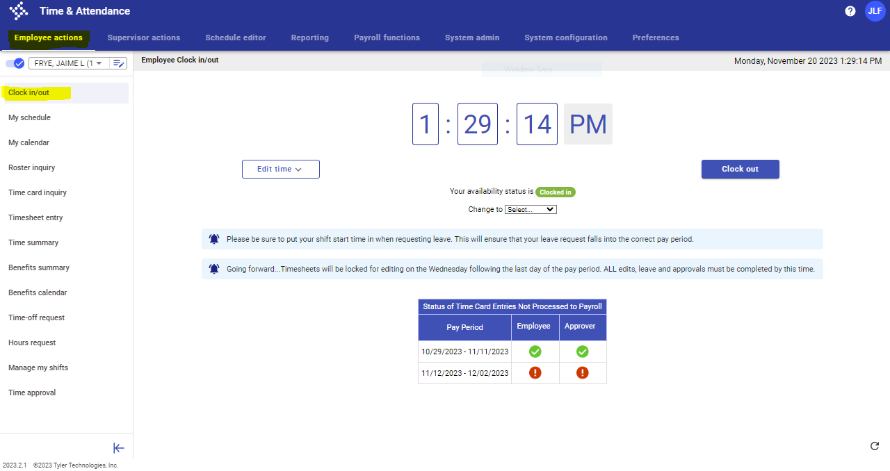

To clock in:
- Select Clock In/Out from the menu.
- Click the Clock In button. When you clock in, your Availability Status changes to Clocked In, allowing others to see that you have clocked-in and are available.
A clock-in transaction is not considered complete until you clock out, which closes the entry.
- To clock out and complete the transaction, click the Clock Out button.
When you clock out, your Availability Status changes to Clocked Out.
For clock-in/out entries, Time Card Inquiry displays the time card as a completed entry with no violations.

Edit Info
When you make entries using the clock-in/out process, they are automatically associated with the default pay code, position, and job costing values assigned to you. If you work multiple assignments or need to track your time against different projects or accounts, or if you otherwise need to modify the default codes for your time, you can use the Edit Info button on the Clock In/Out screen.

To change the codes that are associated with a Clock In/Out entry:
- On the Clock In/Out screen, click the Edit Info button. 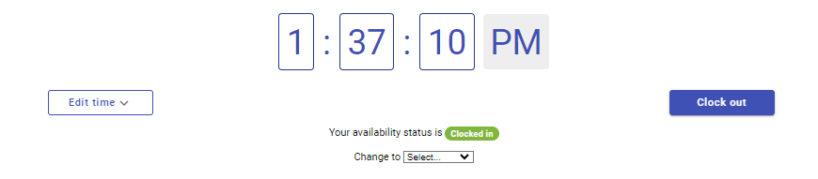
- Using the drop down menu under “type”, select the codes that should be applied to your time, by selecting the appropriate code from the list. Enter any applicable text, as required.
- To display a list of available codes for a secondary position, if available, use the drop down list located in the position field.
- Once all fields have been completed, click Clock In or Clock Out to complete the transaction.
You can select a department, location, or shift code in the system, regardless of security access granted by your role, but you are only able to select position and cert/req codes that are assigned to you in your Employee Master file.

Timesheet Entry
Timesheet Entry is primarily used for tracking exceptions to regular time. Using this option, you can edit, add, and delete any time entries that are in the specified period.

If you are a supervisor, use this screen to review timesheet details entered by employees. 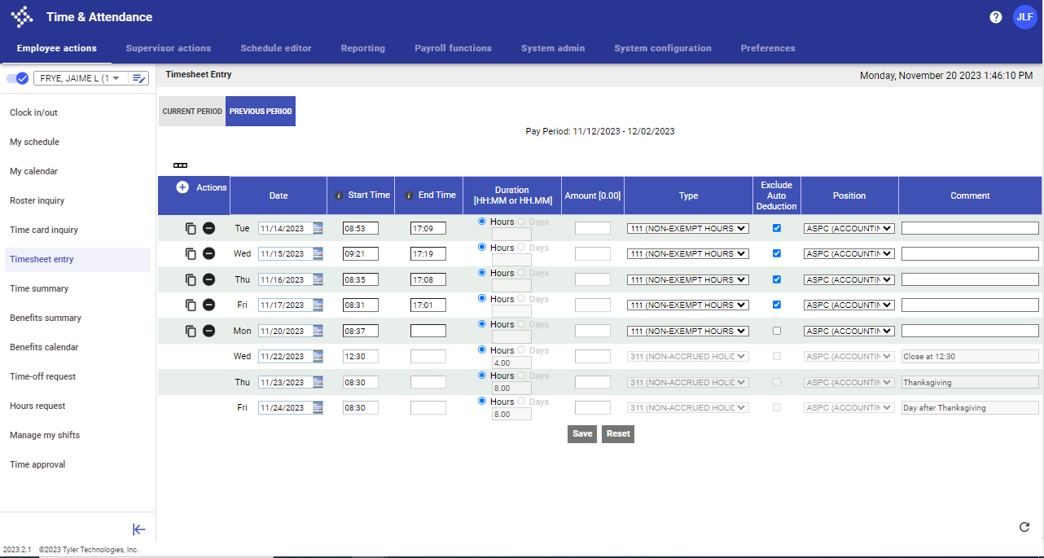

If you have edit permission, you can update the pay code in the Type list for an individual entry. Available pay codes are determined by the settings established in the employees’ master file.

If a clocking policy is enabled for department, location, shift, or job costing updates, you can modify this information as well.

Managing Timesheet Data
On the Timesheet Entry screen, use the following options to manage the data on the Current Period tab:
- Click Add to enter a new row.
- Use the Copy button to create a new entry using the selected entry.
- If enabled, use the Exclude Auto Deduction option to remove an automatic deduction from a transaction.
- If enabled, choose from the various job costing fields.
- Use the Delete button to remove an entry.
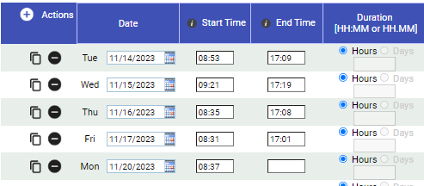

Modified rows are indicated by an asterisk (*) in a yellow box. This does not go away until the time sheet is saved. The program displays the asterisk for all rows if they are unsaved. Employees must select save for any changes to remain.

Saving a time sheet overrides any existing approvals on a time card. Approvals will need to be submitted again.

Time-Off Request
Time-Off Request manages your time-off requests. The Time-Off Request screen displays all information specific to each entry. This data includes the date and time the entry was created, the type of benefit requested, how many hours were requested for each entry, and whether the entry was approved, declined, or is still pending. This screen also displays comments that were made at the time of the entry.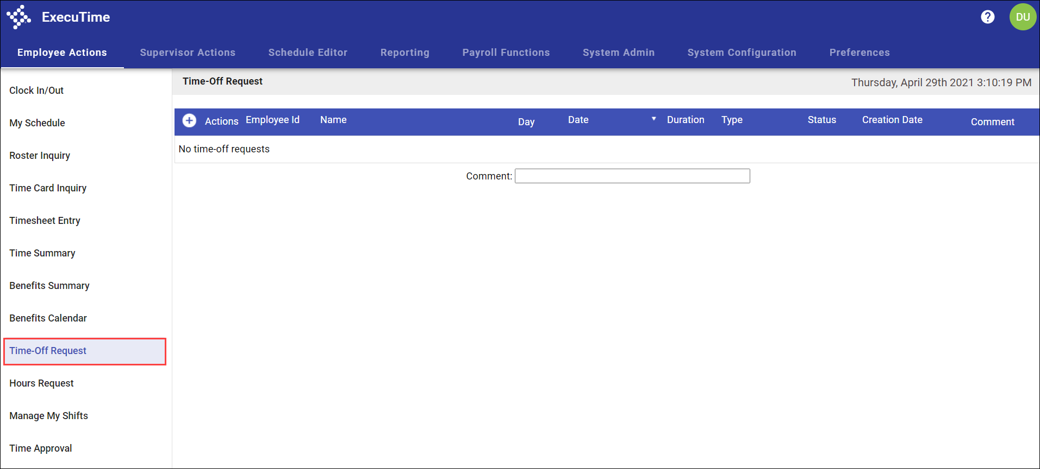

Requesting Time Off
To complete a request for time off:
- Click the Actions button to display the Add Time-Off Request screen.
The fields on this screen vary according to your organization’s requirements.
- From the Benefit Type list, select the type of time off being requested.
- Enter the start and end dates for the time off.
If you do not specify an end date, the request will be recorded as a single-day transaction for the date specified in the Start Date field. If you enter a start and end date, the specified dates and all dates between (including weekends) are included.
- Enter the start time, and enter the number of benefits hours to be used per day.
- Enter a comment, if required or applicable.
- Click Save.
The program displays a Time-off Request Verification screen.
Use the Edit button to modify the request or the Delete button to remove it. You can only edit or delete entries that have a pending status. A supervisor or administrator can edit a request that is approved or declined through the Manage Time-Off program accessed from the Supervisor Actions screen.
**ALL FULL TIME EMPLOYEES, WITH THE EXCEPTION OF LAW ENFORCEMENT AND FIRE, ARE 40 HOUR PER WEEK EMPLOYEES. IF YOU REQUEST MORE LEAVE THAN NEEDED TO MAKE 40 HOURS, YOU WILL NOT BE PAID FOR IT. EDITS TO YOUR LEAVE MUST BE MADE PRIOR TO FINAL APPROVAL. CORRECTIONS WILL NOT BE MADE ONCE PAYROLL HAS BEEN PROCESSED.

Time Card Inquiry
Time Card Inquiry provides a review of time-keeping transactions for the current and previous payroll periods. Using this screen, you can track your working hours. These screens are inquiry-only and you are not allowed to make adjustments unless you have permissions to make job costing splits. Supervisors can access this screen to review employee records.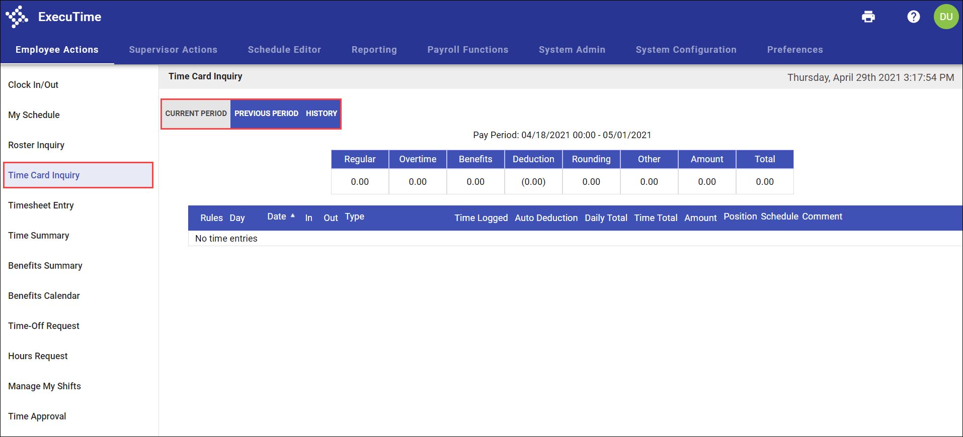

Use the Current Period tab, Previous Period tab, or History tab to review time card information. The History tab stores details for pay periods prior to the current or previous periods. On any tab, hover your pointer over the Information or Incomplete symbol to view additional information.

Time Card Inquiry entries might have Time Entry Details applied to them. In this case, you can expand or collapse the details.

Time Entry Details
Time Entry Details provide time transactions that are created by the system, such as overtime or shift differential entries. Since these entries are not manually created, they cannot be updated.

The Time Card Inquiry screen displays these entries just after the original transaction. According to the UI Environment Flags settings for your interface, the details might display in the expanded or collapsed format.

These entries can be set to default by an overtime policy, compensatory time policy, or shift differential configuration.

Time Approval
Time Approval allows you to review and approve your time prior to submitting it to payroll. With your unique user ID and encrypted password, the initials you enter for the approval are considered a digital signature for recordkeeping. Approvals can be completed on a line-by-line basis or all at once.

You can also use this screen to see when a supervisor approves transactions or makes comments.
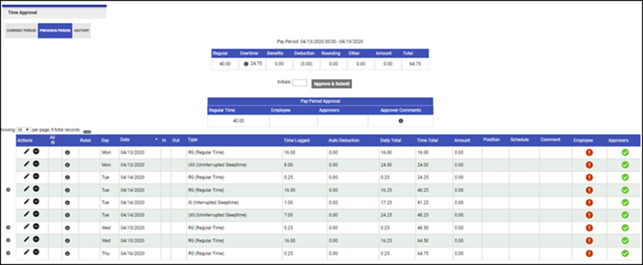

When you approve a time card, your initials are automatically stored in the Employee column. The Supervisor column is not populated until a supervisor approves the time card. If any of these entries appear inaccurate, a supervisor can change them through Employee Time Maintenance.

Any inquiries or edits made after approval, with reset the approval process. Approval workflow will need to be completed again.

Benefits Summary
Benefits Summary displays your available benefit time. The information on this screen is display only.
Supervisors can also use this screen to check the benefits that are available to an employee, or benefits that an employee has requested in the past.
The Benefits Summary screen sorts the details by tab:
Benefits displayed will vary, and are determined by the employees’ position.
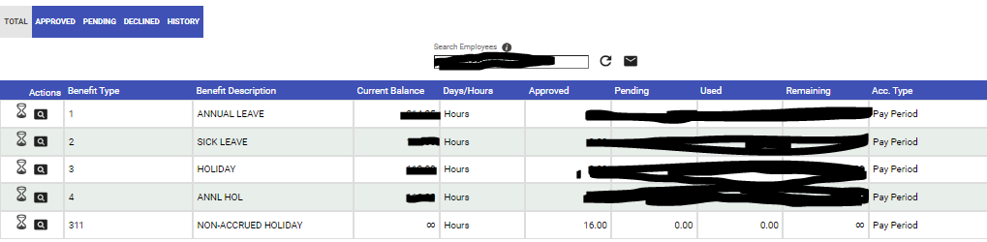

- Total tab—Displays total accruals. This includes any specific information pertaining to benefits in the current period such as time available, used, or pending. The Total tab also indicates the benefit type, current balance, approved time, pending time, used time, remaining, time, accrual type, and benefit description.
  - Used displays the approved benefit time that is being used. This updates the user’s current balance to allow a more accurate representation of the employee’s actual remaining balance after payroll processing completes. This column is only applicable when the Two Step Move to Payroll process is enabled.
  - Current Balance shows how much of each benefit type is available to the employee. This information is drawn from the payroll system each night, so it is current and accurate.
  - Approved records for the number of hours that have been requested and approved by the supervisor and that have not been processed through the move to the payroll system. This column’s contents are subtracted from the Current Balance column in the page calculation.
  - Declined shows the number of hours that have been declined by the supervisor and do not count against the remaining or current balance.
  - Pending includes all time that has been requested and has not yet been approved by a supervisor. This column is also considered in the calculation formula to determine a remaining amount to show in the last column.
  - Accrual Type describes the interval at which the benefit is accrued on a regular basis (for example, by pay period or by yearly allotment).
- Approved, Pending, and Declined tabs—Provide details for specific types of entries. For example, click the Approved tab to view only time that has been approved.
- History tab—Provides an historical view for previous entries.
- To view accruals and deductions for a specific benefit, select the magnifying glass to the left of the table.
- Selecting the hour glass will display a view of all benefits requested, of processing status, for each specific benefit.

