Supervisor Approvals Using Time & Attendance
Supervisors must approve the time entry data using Time & Attendance.

Employee Time Summary
The Employee Time Summary menu option provides an at-a-glance view of all employee time for current and previous payroll periods. It indicates if time has been approved, if policies have been managed, if there are any violations within the employee’s time sheet, as well as if employees and supervisors have reviewed and approved the time sheets. 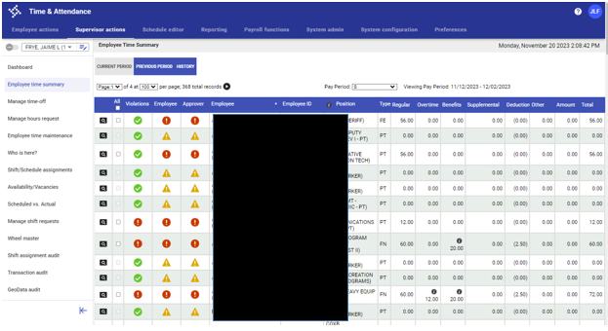

To review employee transactions for the current, previous, or historical payroll period:
- Select the Current Period, Previous Period, or History tab.
- Click the magnifying glass icon to display the Time Approvals screen, where you can add, update, or delete transactions on the employee’s time card.
- By default, the details sort according to the Employee column, with the sort criteria of last name. Use the column headings to sort the Violations, Employee, Supervisor, Name, and Type columns in ascending or descending order. (The default value for each sort order is ascending; click the header to refresh the data in descending order. Click the header again to return to ascending order.)
The Time Summary option is only available when it is enabled by your system administrator through the UI Environment Flags option in System Administration. Contact payroll to enable this option if you do not have access, and would like to.

Time Approvals
Time Approvals provides the time entry activity and time approval options. Use this screen to review and approve employees’ time records prior to submitting the records to payroll. The History tab provides approval information for processed payrolls. 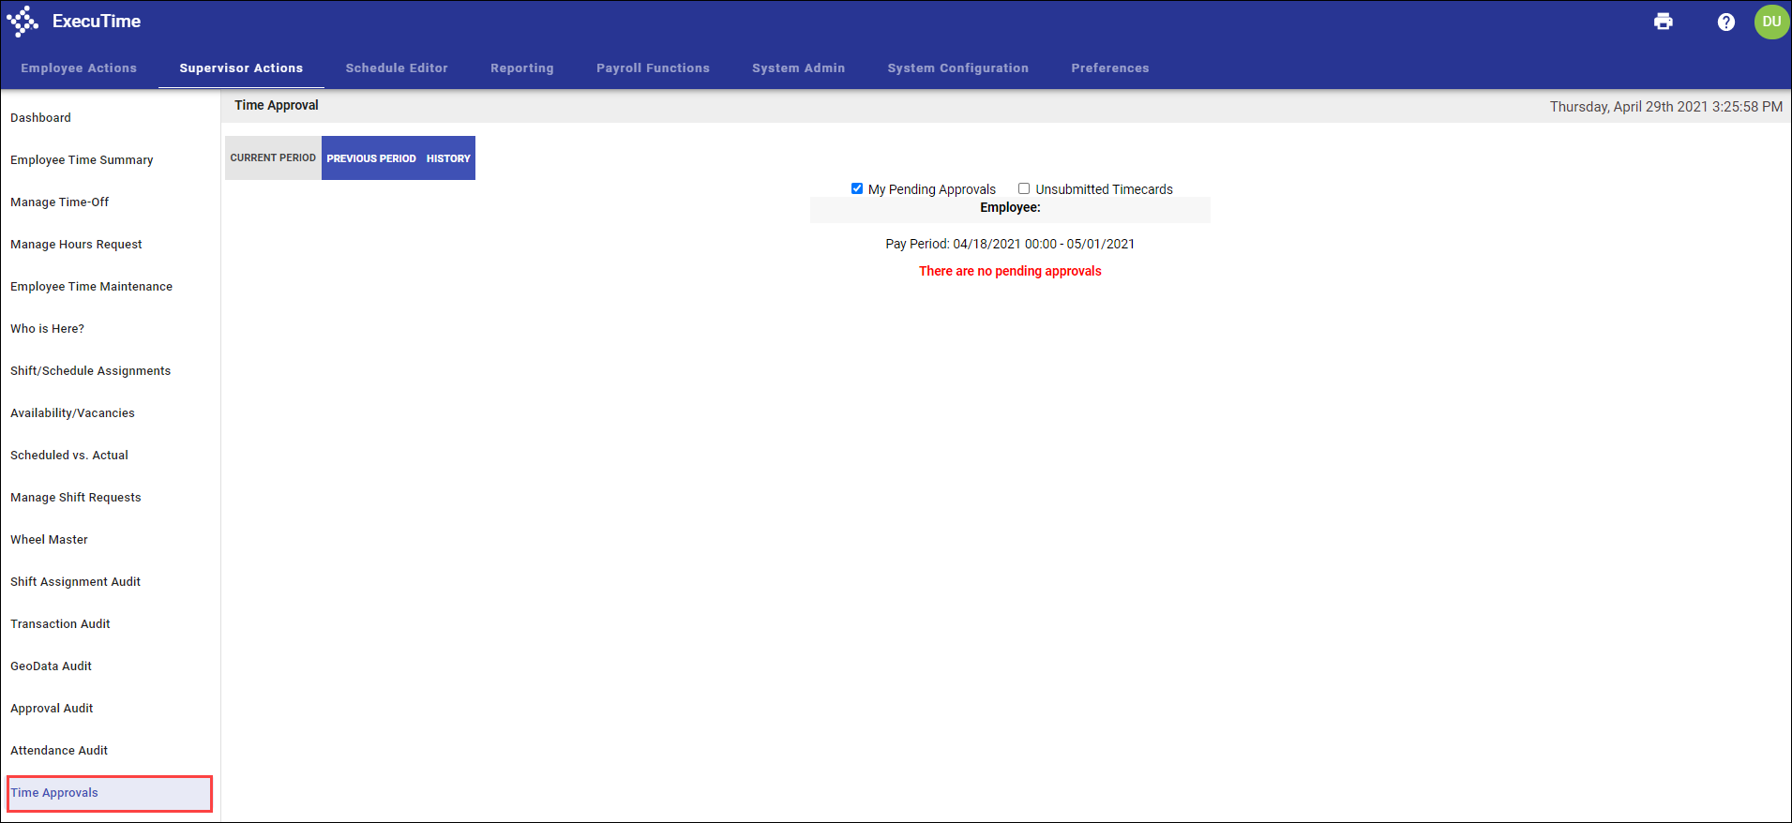

Use the My Pending Approvals and Unsubmitted Timecard checkboxes to narrow your results.

The steps of approval and the type of approval (such as time approval, time-off request, or hours request) are determined by your system administrator under the workflow approvers rule in Workflow Management. Approvals can be completed on a line-by-line basis or all at once.

If you use the page navigation options (< and >), the program skips the current time card and moves to the next one without making any changes.

To review and approve a time transaction:
- Select the applicable pay period tab: Current Period or Previous Period.
- From the Approval Type field, select the approval level (employee or approver).
- Select the checkboxes for the entries to approve or use the “all” checkbox to select all available entries.
- Enter your initials.
- Click Approve.
The program completes the applicable approval type column with your initials.

Editing Time
With the appropriate permissions, you can edit time sheet entries from the Time Approvals screen.
- Click the pencil icon for the record to update.
- Update the details as required.
- Click Save.
The program displays a verification screen and then returns to the Time Approvals screen.
Use the Reset option to return all fields to their original values. To return to the Time Approvals screen without saving changes, use the Back button.

Adding Clock In/Out Entries
The Add New Clock In/Out Entry option allows you to add a new time entry record. This option is available if you have the appropriate permissions assigned to your user role.

To enter a record:
- Click Add Clock In/Out Entry to display the Add Clock In/Out Entry screen.
- Enter the start date and time for the record.
- Enter the end date and time for the record.
- Update a department or job costing information, as required.
- If applicable, select the time type from the Type list. Only timekeeping types that are allowed for a Clock In/Out Entry are available.
- If enabled, and appropriate, select the Exclude Auto Deduction checkbox to indicate that this transaction should not include an automatic deduction.
- Enter a comment, if applicable.
- Select the Override Auto Deduction Violations option to override automatic deductions. If this option is not selected, the time card displays the incomplete symbol for the entry.
- Click Save.
The program displays a verification screen and then returns to the main Time Approval screen.
Use the Reset option to return all fields to their original values, or to return to the Time Approval screen without saving changes, use the Back button.

Adding Benefit or Other Entries
The Add New Time Entry option allows you to add a new time entry record, such as leave. This option is available if you have the appropriate permissions assigned to your user role.

To add a new time entry record:
- Click Add New Time Entry.
- Select the time type from the Type list.
- Enter the start and end dates.
- Indicate the hours per day. Use the hh.mm or hh:mm format.
- Add a comment, as applicable.
- Select the Override Schedule Violations option to allow this entry to violate the employee’s schedule. If this option is not selected and the time entry record violates the schedule, the time card entry displays the Incomplete symbol and includes a schedule violation.
- Select the Override Auto Deduction Violations option to override automatic deductions. If this option is not selected, the time card displays the Incomplete symbol for the entry.
- Click Save.
The program displays a verification screen and then returns to the main Time Approval screen.
Use the Reset option to return all fields to their original values, or to return to the Time Approval screen without saving changes, use the Back button.

